**CHANDIGARH UNIVERSITY**

**UNIVERSITY INSTITUTE OF ENGINEERING**

**DEPARTMENT OF COMPUTER SCIENCE AND ENGINEERING**



|  |  |
| --- | --- |
| **Submitted by:** Yash Gupta (20BCS5009) | **Submitted To:** Er. Daulat Ram (13701) |
| **Subject Name:** | Project Based Learning in Java |
| **Subject Code:** | 20CSP-321 |
| **Branch:** | CSE |
| **Semester:** | 5th |

LAB INDEX

|  |  |  |  |  |  |  |  |
| --- | --- | --- | --- | --- | --- | --- | --- |
| Sr.  No | Program | Date |  | Evaluation | | | Sign |
| LW  (12) | VV  (8) | FW  (10) | Total (30) |
| 1. |  |  |  |  |  |  |  |
| 2. |  |  |  |  |  |  |  |
| 3. |  |  |  |  |  |  |  |
| 4. |  |  |  |  |  |  |  |
| 5. |  |  |  |  |  |  |  |

# 

# Experiment-2.1

Aim :-

Write a program to collect and store all the cards to assist the users in finding all the cards in a given

symbol.

This cards game consist of N number of cards. Get N number of cards details from the user and store

the values in Card object with the attributes symbol and number.

Store all the cards in a map with symbol as its key and list of cards as its value. Map is used here to

easily group all the cards based on their symbol.

Once all the details are captured print all the distinct symbols in alphabetical order from the Map. For

each symbol print all the card details, number of cards and their sum respectively.

Code and output:

import java.util.*;  
  
public class card {  
  
 public static void main(String[] args){  
 Scanner input = new Scanner(System.*in*);  
 List<Integer> valueList = new ArrayList<Integer>();  
 TreeMap<String, List<Integer>> mapObj = new TreeMap<String, List<Integer>>();  
 int totalCards, index, value, sum = 0, count = 0;  
  
 System.*out*.println("ENTER NUMBER OF CARDS : ");  
 totalCards = input.nextInt();  
 String symbol;  
  
 for(index = 1; index <= totalCards; index++){  
 System.*out*.println("ENTER CARD" + " " + index);  
 symbol = input.next();  
 value = input.nextInt();  
  
 if(mapObj.containsKey(symbol)){  
 valueList = mapObj.get(symbol);  
 valueList.add(value);  
 }else{  
 valueList = new ArrayList<Integer>();  
 valueList.add(value);  
 mapObj.put(symbol, valueList);  
 }  
 }  
  
 System.*out*.println("DISTINCT SYMBOLS ARE :");  
 for(Map.Entry getData : mapObj.entrySet()){  
 System.*out*.print(getData.getKey() + " ");  
  
 }  
 System.*out*.println();  
  
 for(Map.Entry getData : mapObj.entrySet()){  
 System.*out*.println("CARDS IN " + getData.getKey() + " SYMBOL :");  
 ArrayList<Integer> temp = (ArrayList<Integer>) getData.getValue();  
 Iterator itr= temp.iterator();  
 while(itr.hasNext())  
 {  
 count++;  
 int val = (int) itr.next();  
 System.*out*.print(getData.getKey());  
 System.*out*.println(" " + val);  
 sum += val;  
 }  
  
 System.*out*.println("NUMBER OF CARDS : " + count);  
 System.*out*.println("SUM OF NUMBERS : " + sum);  
 sum = 0;  
 }  
 }  
}

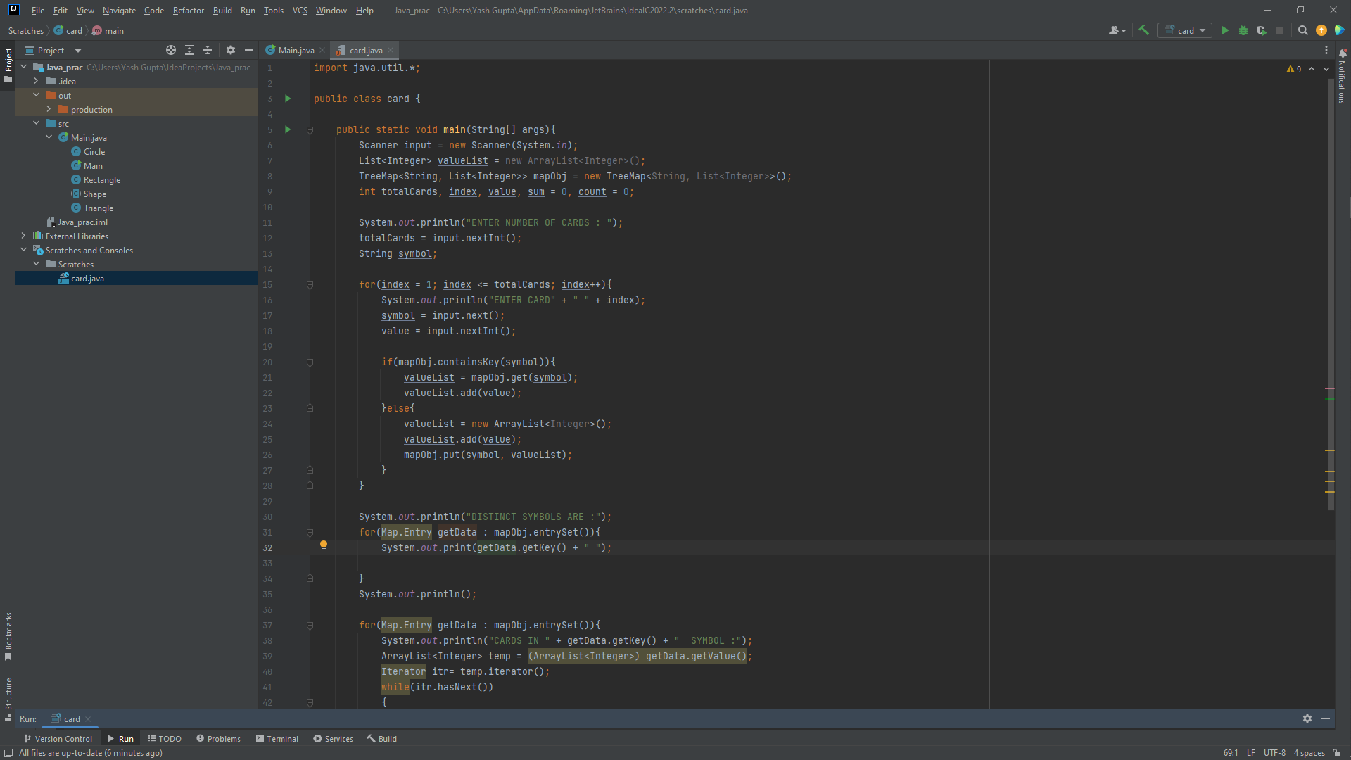

Output **:-**

